MEMBERSHIP
CATEGORIES



FAMILY
45 & Under

CORPORATE
INDIVIDUAL

The Power of Membership

The Rotary Club of Tucson (RCOT) offers four unique membership categories for individuals or companies looking to join one of the largest service clubs in the USA. Our club is the largest and second oldest in Arizona and has been effecting positive changes in Tucson since 1921. Rotarians join together as leaders to exchange ideas, take action, and change lives.

RCOT supports scholarships for University of Arizona and Pima Community College students. We sponsor College Clubs (ages 18-25) and High School Clubs (ages 14-18) throughout Pima County. The Rotary Youth Leadership (RYLA) programs improve leadership skills in high school-age students.
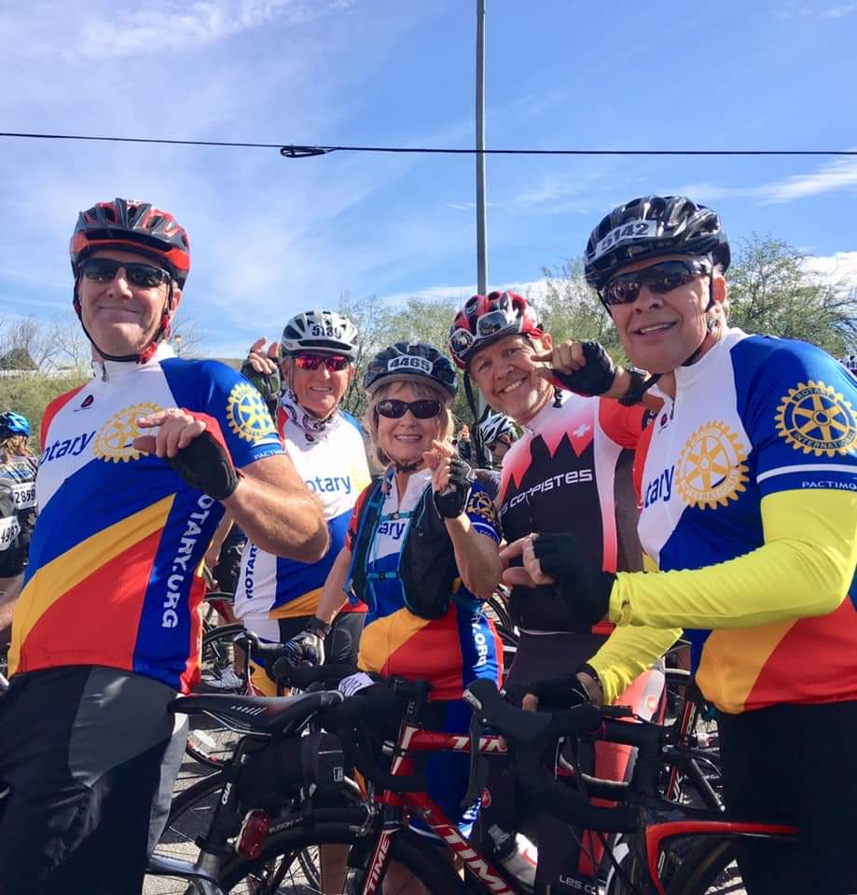
With the 19th annual Tucson Classics Car Show in 2025, RCOT has raised over $3 million for local charities. Through our current primary charity partner, Pima Community College Foundation and Pima Community College’s Workforce Development Program at the Center of Opportunity, we are helping families earn a livable wage and move from temporary housing to permanent housing.

RCOT focuses on the values of service above self by offering weekly programs on community issues, while providing fellowship and networking opportunities with like-minded civic and business professionals.

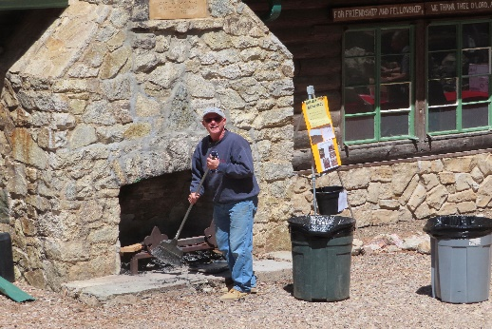
Through a commitment to providing hands-on service in cooperation with projects that have local and global impacts, Rotarians ring bells for the Salvation Army, organize and participate in the Ride to End Polio as part of El Tour de Tucson and support humanitarian missions in various parts of the world. We also, for example, donate and plant trees in the Tucson Garden District Neighborhoods, have volunteer days of service at the Triangle Y YMCA Ranch in Oracle, and help pack food at the Community Food Bank, along with many other service projects.

Involved and engaged members are vital to the activities and services provided by the Rotary Club of Tucson. And YOU are vital to our continuing efforts to empower youth, improve health, promote peace, and advance our communities in all corners of the globe.
Rotary Club of Tucson - Office
3900 East Timrod Street, Suite 4
Tucson, Arizona 85711
Phone: (520) 623-2281
Email: rotary@tucsonrotary.org
Website: TucsonRotary.org
Membership Packets are available at meetings, and at the club office. To learn more, please come as a guest to our next meeting.

Make friends for a lifetime while together we improve our community and the world.

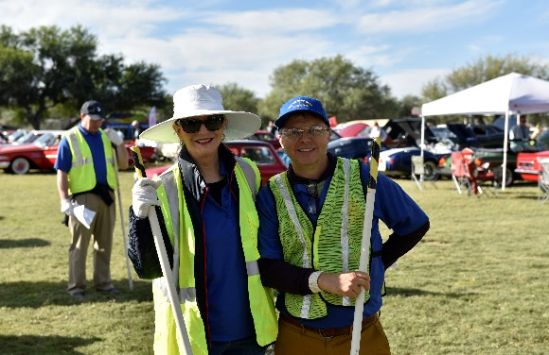



Meets Wednesdays, 12:00pm – 1:20pm, at the Tucson Convention Center, 260 S. Church Ave., Tucson, Arizona
RCOT Membership Opportunities
Membership in the Rotary Club of Tucson is by invitation of a local club member. The best way to find out about membership is to attend one or more of our club meetings with a Rotarian who can explain the organization. If you do not know a member, we encourage you to contact our Club office at (520) 623-2281 or rotary@tucsonrotary.org.
_____________________________________________________________________________________________
Individual Membership is the traditional Rotary membership. These members gain all of the privileges and responsibilities that come with being a Rotarian. These include supporting the Rotary Four-Way Test, being familiar with Rotary programs, and serving as an ambassador for Rotary. Fifty percent attendance at weekly meetings, events and functions is encouraged but not required. Members are also encouraged to serve on at least one committee and make a personal contribution annually to the Rotary Club of Tucson Foundation, which funds all of our service projects. Individual Membership dues are currently $365 per quarter which includes weekly meals.
45 & Under Membership carries all the benefits of an Individual Membership. The Club Board recognizes that these members play an integral role in the future of our club but may not have the financial resources or available time to attend weekly meetings at this point in their careers. With this in mind, for those 45 and under, Membership dues are reduced (currently $240 per quarter) and include seven flexible meetings per quarter. Any lunch meetings attended over seven will be billed at the lunch member rate (currently $34).

Corporate Membership is designed for companies that want to maintain multiple Rotary memberships. One Designated Corporate Member and unlimited active/regular members may join under the one-time $1000 initiation fee paid for by the sponsor organization. Please contact our office for a more detailed description of this membership category.

Family Membership is available to a spouse or partner or immediate family member (over 18) of a Rotary Club of Tucson member. There are no requirements for attendance and the family member cannot hold elected office or vote. The cost of a Family Membership is $95 per quarter plus the cost of any lunch or event attended, in addition to a one-time application fee of $50.

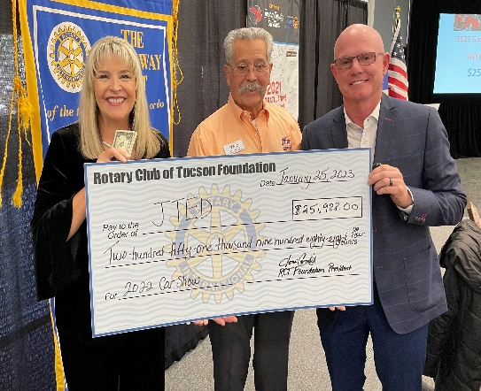

Revised 7-1-24

With you we can accomplish even more.
Please
Join The Rotary Club of Tucson today!

